Creating Groups in Genie

In order to show a better visualization of a Bayesian network, the MARV interface uses groups as a way to display a network in a hierarchical fashion. This tutorial will show how groups can be created using Genie so that MARV can do an effective visualization.

The following example network will be used for this tutorial.

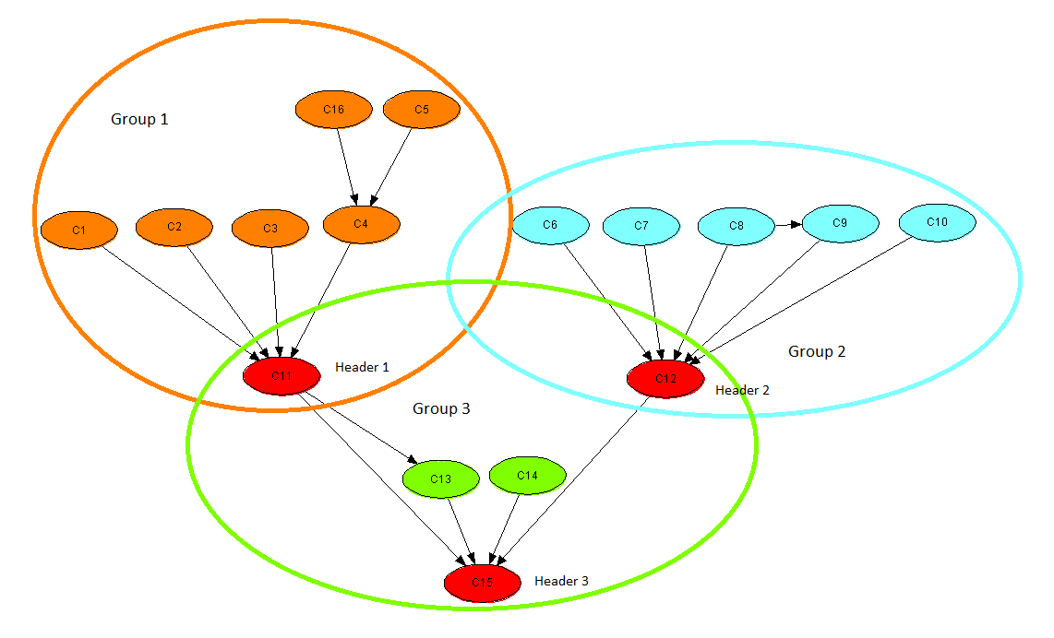

This network has three conceptual groups named 1, 2, and 3. Each group has a special node denoted *header*. Each group can only have one header. Here C11 is header of group 1, C12 of group 2 and C15 of group 3.

Some nodes can belong to two or more different groups. This is okay. In our example above, the node C11 belongs to both group 1 and 3. However, it is the header only of group 1.

The groups are stored in the network using user properties. To add your own user properties, open a network in Genie, right click on node, select ‘Node Properties’ and then switch to the ‘User Properties’ tab.

To add a new user property, click on the ‘Add’ button. We can now add a user property named groups. In the values text box, enter a comma separated list of groups that the node belongs to. The following diagram shows this for node C1.

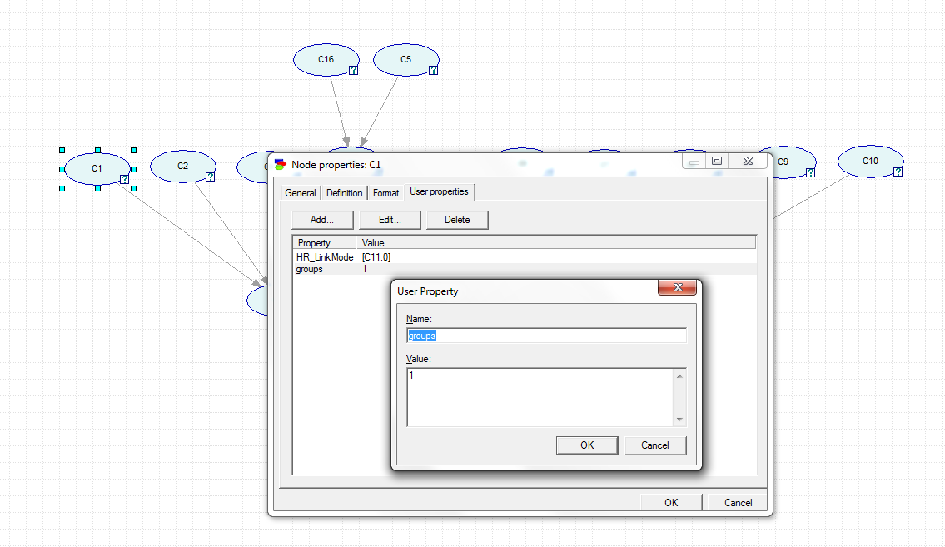

C1 belongs only to group 1 so we just enter “1”. If it had belonged to more than one group, say 1 and 3, we would enter “1,3”.

The same procedure is followed for header nodes too but with some caveats. The next diagram shows how header groups are specified.

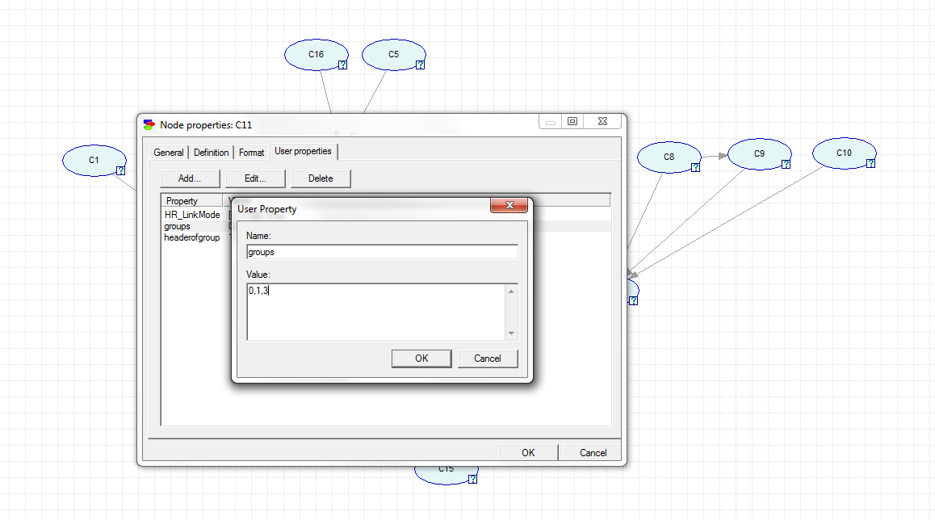

Again, we add a new user property to the header node C11 as described above. Since C11 belongs both to group 1 and 3 we add “1” and “3” separated by commas. However, this is also a header node. Thus we also add another group “0” to indicate that this is the header node.

But which group is this the header of, 1 or 3? To indicate this, we must add another user property headerofgroup to header nodes. This property is not needed for non-header nodes.

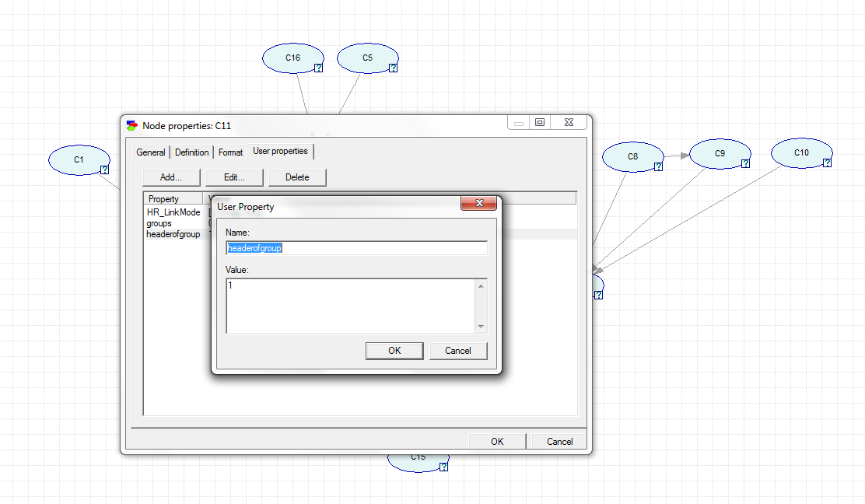

C11 is the header of group 1 so we add “1” as the value.

For node C12, which is also a header node, groups will be “0,2,3” since it is a header, and belongs to groups 2 and 3. And headerofgroup will be “2”. For the header node C15, groups = “0,3” and headerofgroup = “3”.

The network file is now ready to be viewed in MARV.

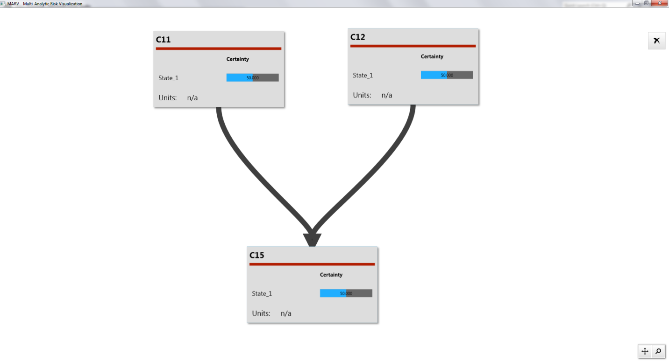

Only the headers are visible on startup. Expanding header C11 reveals group 1.

